RTL Circuits: NAND GATE
Overview:
This invertor circuit takes two inputs of either a “HIGH” or “LOW” signal. Dependant on the combination of inputs, the combined signal will be inverted and either illuminate or turn off the LED. The logic circuit is constructed using a combination of transistors and resistors.

Equipment:
- 2× 10kΩ and 1× 1kΩ resistor
- 2× 2N3904 BJTs
- LED
- 5V Linear Breadboard Supply (details in README)

Schematic:
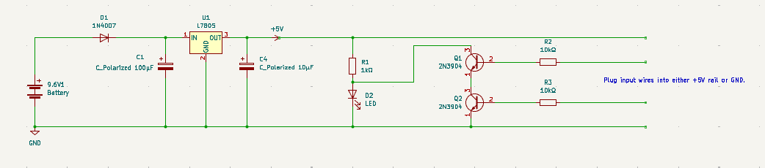
Figure 1: NAND Gate circuit connected to linear power supply

Truth Table:

Input (X) | Input (Y) | Output (Z)
0 | 0 | 1
0 | 1 | 1
1 | 0 | 1
1 | 1 | 0

Circuit Operation
The floating wire inputs connected to the bases of the 2N3904 BJTs can be connected alternately between the +5V rail (logic “HIGH”, “1”) and GND (logic “ZERO”, “0”).
Theoretically, when our combination of input logic is:
- Q1 – Logic 0, Q2 – Logic 0
Both BJTs are switched off and in cut-off operation as the voltage across the base-emitter junction is essentially 0. The series BJT path acts as an open circuit, hence the LED is on.
- Q1 – Logic 0, Q2 – Logic 1
Although the bottom BJT (Q2) receives base current and turns on, the top BJT (Q1) remains in cutoff as its input is low. The series route to GND via the transistor branch is still broken, so current continues to flow through the LED, keeping it ON.
- Q1 – Logic 1, Q2 – Logic 0
The top BJT (Q1) receives base current, but the bottom BJT (Q2) remains in cutoff. Because Q2 blocks the path to Ground, the series transistor branch remains an open circuit. The current routes through the LED, and it is ON.
- Q1 – Logic 1, Q2 – Logic 1
Both BJTs receive sufficient base current and are driven into saturation. Together, they form a continuous, low-resistance path to GND. This branch effectively acts as a short circuit, starving the parallel LED branch of current and pulling the output node LOW, so the LED is OFF.

Experimental Calculations
When the LED was on (output logic HIGH), the BJT branch was in cut-off mode, hence the supply current was forced through the load LED. The measured output node was clamped at 2.54V due the forward voltage drop across the blue LED. This value may change with different colour LEDs as different amounts of energy are required for different colours.
When both base inputs were driven HIGH, the stacked BJTs entered saturation and pulled the output node down to a measured 21mV, successfully starving the LED of current. Theoretically, the total voltage drop across a stacked logic gate should represent the sum of the individual collector-emitter saturation voltages ($V_{out}=V_{CE\left(sat\right)1}+V_{CE\left(sat\right)2}$) which typically yields a much higher value. This unusually low measured voltage is attributed to the BJTs being driven into deep saturation relative to the low collector current, which is heavily restricted by the 1kΩ pull-up resistor.
Furthermore, it must be noted that these specific components were subjected to extreme thermal stress during a prior experimental fault. This thermal event permanently altered the internal junction characteristics of the silicon.

